4-2 Practice
Writing Equations in Slope-Intercept Form

Write an equation of the line that passes through the given point and has the given slope.

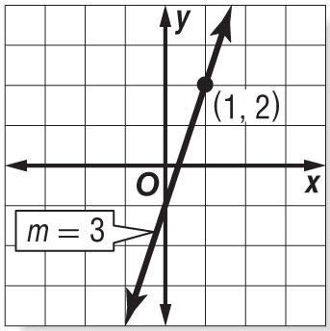
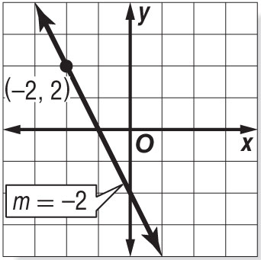
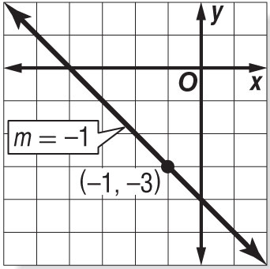
1. 2. 3.

4. (–5, 4); slope –3 5. (4, 3); slope $\frac{1}{2}$ 6. (1, –5); slope $-\frac{3}{2}$

7. (3, 7); slope $\frac{2}{7}$ 8. $\left(-2, \frac{5}{2}\right)$ ; slope $-\frac{1}{2}$ 9. (5, 0); slope 0

Write an equation of the line that passes through each pair of points.

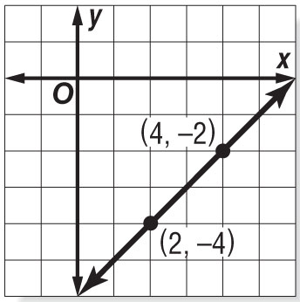
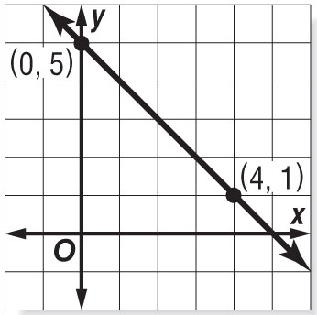
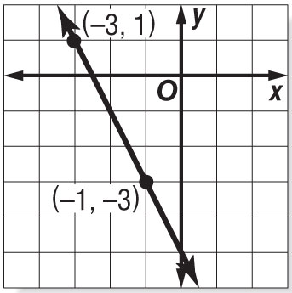
10. 11. 12.

13. (0, –4), (5, –4) 14. (–4, –2), (4, 0) 15. (–2, –3), (4, 5)

16. (0, 1), (5, 3) 17. (–3, 0), (1, –6) 18. (1, 0), (5, –1)

19. DANCE LESSONS The cost for 7 dance lessons is $82. The cost for 11 lessons is $122. Write a linear equation to find the total cost C for ℓ lessons. Then use the equation to find the cost of 4 lessons.

20. WEATHER It is 76°F at the 6000-foot level of a mountain, and 49°F at the 12,000-foot level of the mountain.
Write a linear equation to find the temperature T at an elevation x on the mountain, where x is in thousands of feet.

