Unit 4 – Solving Systems of Linear Equations Name: ________________________________________________
Algebra 1 Due Date: ____________________________________________

Word Problem Packet

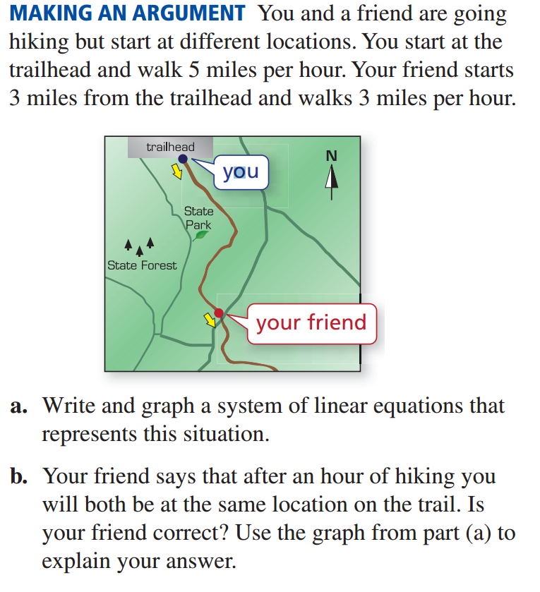

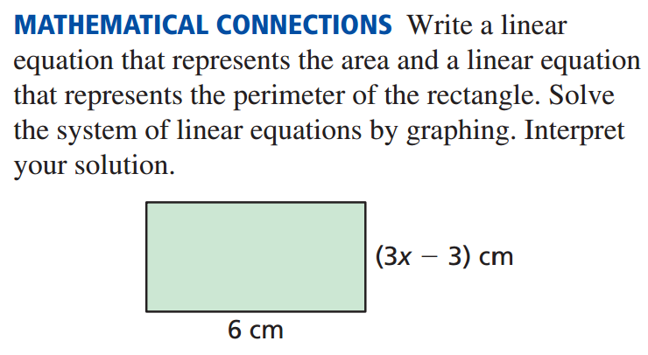

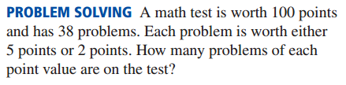

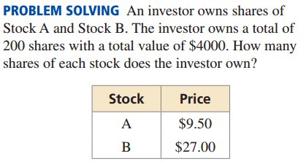

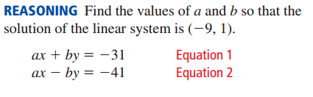

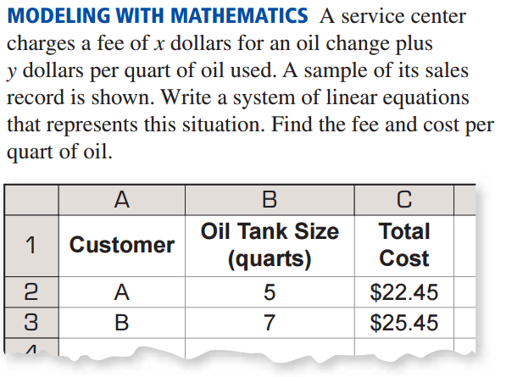

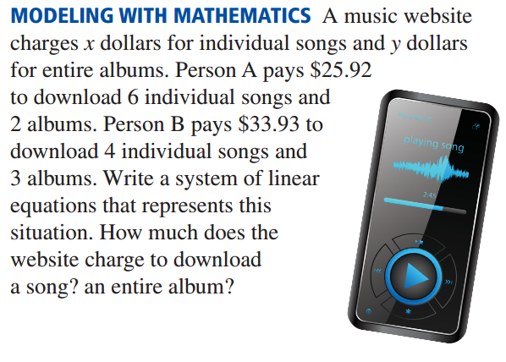

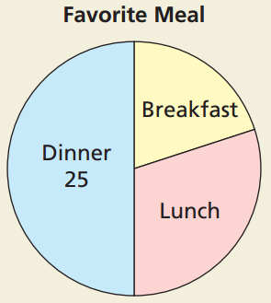
- The circle graph shows the results of a survey in which 50 students were asked about their favorite meal.
- Estimate the number of students who chose breakfast and lunch.

- The number of students who chose lunch was 5 more than the
Number of students who chose breakfast. Write a system of linear
Equations that represents the numbers of students who chose
Breakfast and lunch.

- Explain how you can solve the linear system in part (b) to check your
answers in part (a).

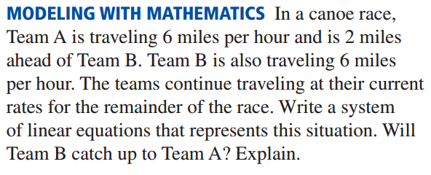

- The graph shows information about the last leg of a 4X200-meter relay for three relay teams. Team A’s runner ran about 7.8 meters per second, Team B’s runner ran about 7.8 meters per second, and Team C’s runner ran about 8.8 meters per second.
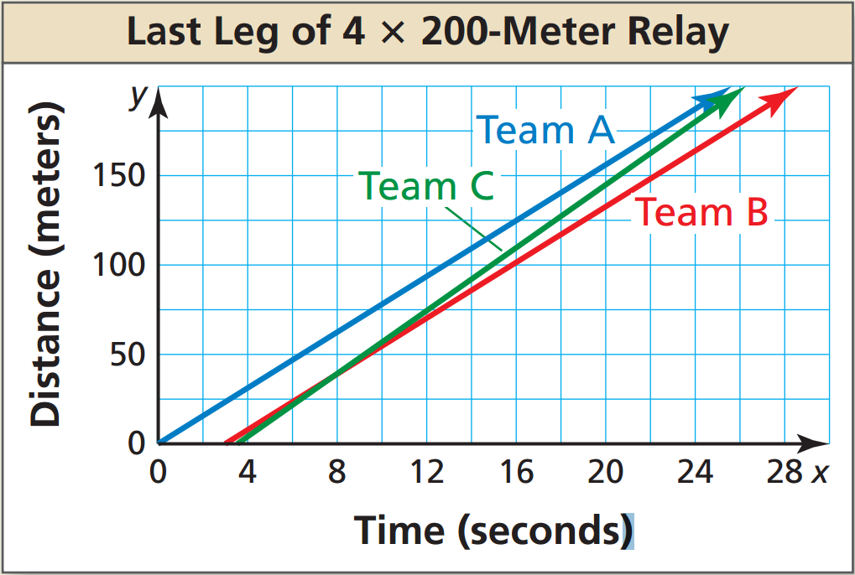
- Estimate the distance at which Team C’s
runner passed Team B’s runner.

- If the race was longer, could Team C’s
runner have passed Team A’s runner?
Explain.

- If the race was longer, could Team B’s runner have passed Team A’s runner? Explain.

