Name Hour

Graphing y = ax^2

HW 8.1

In Exercises 1–6, graph the function. Compare the graph to the graph   
of 

1.  2.  3. 

4.  5.  6. 

In Exercises 7–9, use a graphing calculator to graph the function. Compare the graph to the graph of 

7.  8.  9. 

10. The arch support of a bridge can be modeled by  where *x* and   
*y* are measured in feet.

a. The width of the arch is 800 feet. Describe the domain of the function. Explain.

b. Use a graphing calculator to graph the function, using the domain in part (a). Find the height of the arch.

11. Is the *y*-intercept of the graph of always 0? Explain.

In Exercises 12–15, determine whether the statement is *always*, *sometimes*,   
or *never* true. Explain your reasoning.

12. The graph of  is narrower than the graph of  when 

13. The graph of  opens in the same direction as the graph of  when 

14. The graph of  opens in the same direction as the graph of when 

15. The graph of  opens in the same direction as the graph of when 

Name Date

Practice B

8.1

In Exercises 1–6, graph the function. Compare the graph to the graph   
of 

1.  2.  3. 

4.  5.  6. 

7. Describe and correct the error in graphing and comparing  and 

The graphs have the same vertex and   
 the same axis of symmetry. The   
 graph of  is a reflection in   
 the *x*-axis of the graph of 

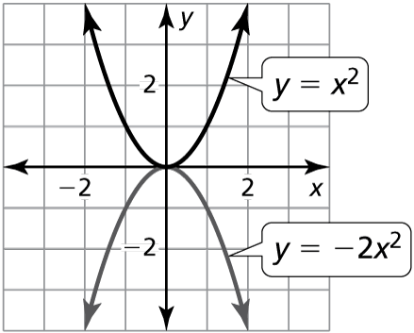

8. The arch support of a bridge can be modeled by , where *x* and *y* are measured in feet.

a. The width of the arch is 900 feet. Describe the domain of the function. Explain.

b. Use a graphing calculator to graph the function, using the domain in part (a). Find the height of the arch.

9. A parabola opens down and passes through the points  and .   
How do you know that  could be the vertex?

10. Given the parabola

a. Find the value of *a* when the graph passes through  and 

b. Find the value of *a* when the graph passes through  and  Explain.