Name_____________________________ Hour ___________

Algebra 1 Homework: Due Monday 11/2

All work must be shown on a separate sheet of paper.

In Exercises 1 and 2, describe the slope of the line. Then find the slope.

1. 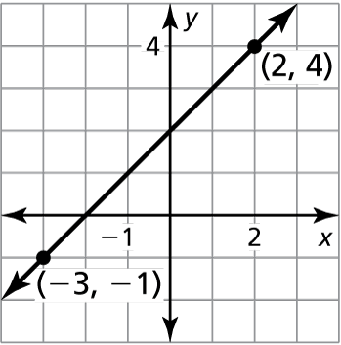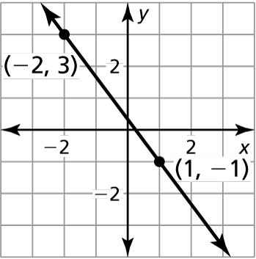 2.

the points represented by the table lie on a line. Find the slope of the line.

|  |  |  |  |  |
| --- | --- | --- | --- | --- |
| *x* | 0 | 2 | 5 | 7 |
| *y* | 3 | 3 | 3 | 3 |

1. 4.

|  |  |  |  |  |
| --- | --- | --- | --- | --- |
| *x* | −2 | 1 | 4 | 7 |
| *y* | 0 | 1 | 2 | 3 |

Find the slope and the *y*-intercept of the graph of the linear equation.

5.  6. 

7.  8. 

Graph the linear equation. Identify the *x*-intercept.

9.  10. 

11.  12. 

Graph the function with the given description. Identify   
the slope, *y*-intercept, and *x*-intercept of the graph.

13. A linear function *f* models a relationship in which the dependent variable decreases 3 units for every 2 units the independent variable increases. The   
value of the function at 0 is 5.

14. A linear function *g* models a relationship in which the dependent variable increases 2 units for every 7 units the independent variable increases. The   
value of the function at 0 is −1.

Name_____________________________ Hour ___________

Algebra 1 Homework: Due Monday 11/2

All work must be shown on a separate sheet of paper.

Algebra 1 Homework: Due Monday 11/2

All work must be shown on a separate sheet of paper.

In Exercises 1 and 2, describe the slope of the line. Then find the slope.

1.  2.

the points represented by the table lie on a line. Find the slope of the line.

|  |  |  |  |  |
| --- | --- | --- | --- | --- |
| *x* | −2 | 1 | 4 | 7 |
| *y* | 0 | 1 | 2 | 3 |

1. 4.

|  |  |  |  |  |
| --- | --- | --- | --- | --- |
| *x* | 0 | 2 | 5 | 7 |
| *y* | 3 | 3 | 3 | 3 |

Find the slope and the *y*-intercept of the graph of the linear equation.

5.  6. 

7.  8. 

Graph the linear equation. Identify the *x*-intercept.

9.  10. 

11.  12. 

Graph the function with the given description. Identify   
the slope, *y*-intercept, and *x*-intercept of the graph.

13. A linear function *f* models a relationship in which the dependent variable decreases 3 units for every 2 units the independent variable increases. The   
value of the function at 0 is 5.

14. A linear function *g* models a relationship in which the dependent variable increases 2 units for every 7 units the independent variable increases. The   
value of the function at 0 is −1.