Name Hour

Writing and Graphing Inequalities

HW 2.1

Write the sentence as an inequality.

1. A number *x* is less than 2.

2. A number *m* plus 4 is greater than or equal to 7.

Tell whether the value is a solution of the inequality.

3.  4. 

Graph the inequality.

5.  6. 

7.  8. 

9. To qualify for an award, a student volunteers no less than 5 hours each week at the local hospital. Write an inequality that represents how many hours the student volunteers each week.

10. The largest alligator ever caught in Mississippi weighed 727 pounds.

a. Write an inequality that represents the weights of every other   
alligator that has ever lived in Mississippi.

b. Is 750 pounds a solution to your inequality? Explain.

Name Date

Practice B

2.1

In Exercises 1–4, write the sentence as an inequality.

1. A number *x* plus 10 is more than 2.

2. Twelve is no less than the sum of a number *n* and 3.

3. One-half of a number *p* is at least 100.

4. Six is greater than or equal to the quotient of a number *y* and 2.5.

In Exercises 5–10, tell whether the value is a solution of the inequality.

5.  6. 

7.  8. 

9.  10. 

11. The winning swim team earned 245 points. The other teams earned at least   
72 points less.

a. Write an inequality that represents the points that the other teams earned.

b. Was one of the teams able to earn 180 points? Explain.

In Exercises 12–17, graph the inequality.

12.  13.  14. 

15.  16.  17. 

In Exercises 18 and 19, write an inequality that represents the graph.

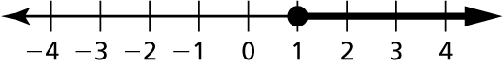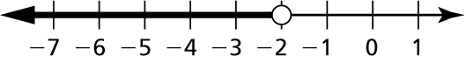 18. 19.

20. An upcoming marathon's qualifying time for males age 18–34 is 3 hours.

a. Write an inequality that represents how many hours a male runner could take to run a marathon in order to qualify.

b. Will a runner with a fastest marathon time of 3 hours 9 minutes qualify for   
the upcoming marathon? Explain.