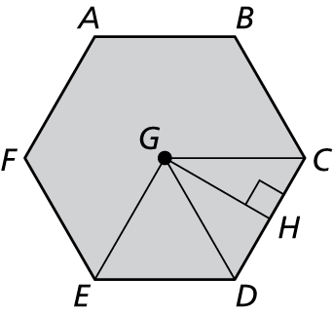Name Hour

Areas of Polygons

HW 11.3

In Exercises 1–4, find the area of the kite or rhombus.

1. 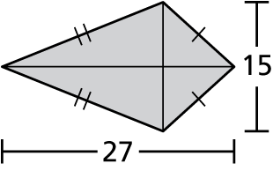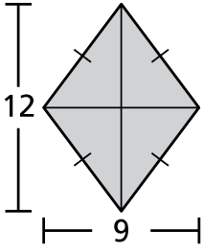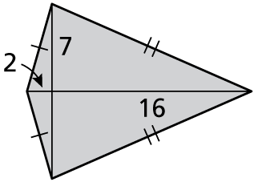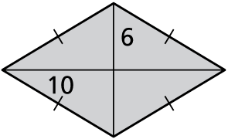 2. 3. 4.

In Exercises 5–8, find the measure of a central angle of a regular polygon with the given number of sides. Round answers to the nearest tenth of a degree, if necessary.

5. 9 sides 6. 16 sides 7. 20 sides 8. 28 sides

In Exercises 9–12, find the given angle measure   
for regular hexagon *ABCDEF*.

9. *m*∠*CGD* 10. *m*∠*CGH*

11. *m*∠*HCG* 12. *m*∠*EGC*

In Exercises 13–17, find the area of the regular polygon.

13. 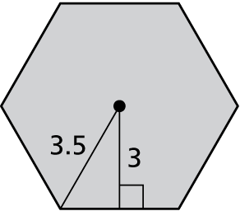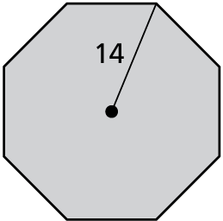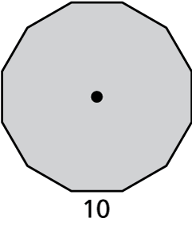 14. 15.

16. a pentagon with an apothem of 7 centimeters

17. a decagon with a radius of 20 meters

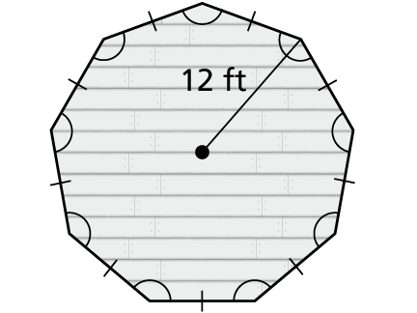 18. Use the figure of the gazebo floor.

a. An arm rail is built around the perimeter of the gazebo. What is the length of the arm rail?

b. A container of wood sealer covers 200 square feet. How many containers of sealer do you need to cover the entire floor of the gazebo? Explain   
your reasoning.

Name Date

Practice B

11.3

In Exercises 1–4, find the area of the kite or rhombus.

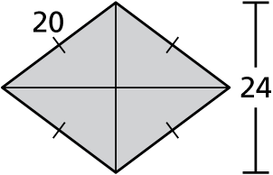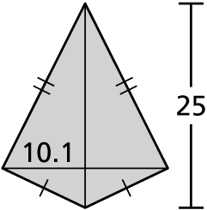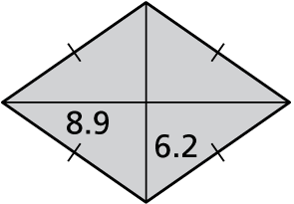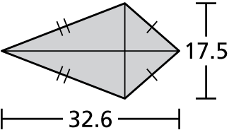 1. 2. 3. 4.

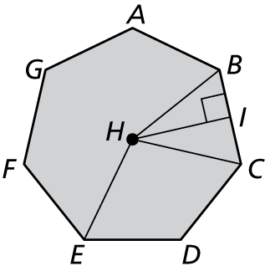In Exercises 5–8, find the given angle measure for regular heptagon *ABCDEFG*. Round your answer to the nearest tenth of a degree, if necessary.

5. *m*∠*BHC* 6. *m*∠*BHI*

7. *m*∠*IBH* 8. *m*∠*EHB*

In Exercises 9–11, find the area of the shaded region.

9. 10. 11. 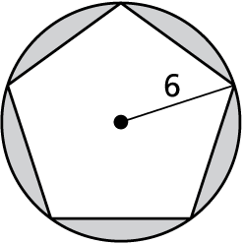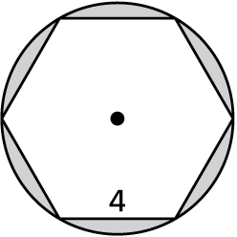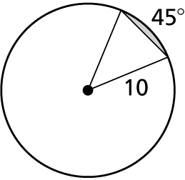

12. The area of a kite is 384 square feet. One diagonal is three times as long as the other diagonal. Find the length of each diagonal.

13. The area of a rhombus is 484 square millimeters. One diagonal is one-half as long as the other diagonal. Find the length of each diagonal.

14. You are laying concrete around a gazebo that is a regular octagon with a radius  
of 8 feet. The concrete will form a circle that extends 15 feet from the vertices   
of the octagon.

a. Sketch a diagram that represents this situation.

b. What is the area of the concrete to the nearest square foot?

15. The perimeter of a regular 11-gon is 16.5 meters. Is this enough information to find the area? If so, find the area and explain your reasoning. If not, explain   
why not.