Name Date

Cumulative Review

Chapter

6

Solve the equation. Check your answer.

1.  2.  3. 

Solve the inequality. Graph the solution, if possible.

4.  5.  6. 

7. The function  represents the amount of money a mechanic charges in dollars for *x* hours of labor and $125 for parts.

a. What is the total bill for 3 hours of labor?

b. How many hours did it take if the bill is $325?

Graph the linear equation.

8.  9.  10. 

Write an equation of the line in slope-intercept form.

11. 12. 13. 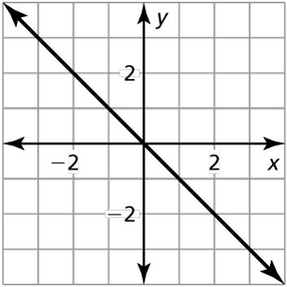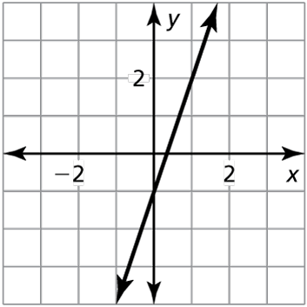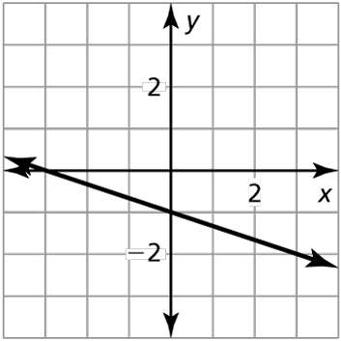

Write an equation in point-slope form of the line that passes through the given point and has the given slope.

14.  15.  16. 

Write an equation of the line in point-slope form that passes through the given point and is perpendicular to the given line.

17.  18.  19. 

Tell whether *x* and *y* show a *positive*, a *negative*, or *no correlation*.

20. 21.

|  |  |  |  |  |  |  |  |
| --- | --- | --- | --- | --- | --- | --- | --- |
| *x* | −2 | −1 | −1 | 0 | 1 | 2 | 2 |
| *y* | −3 | −2 | 1 | 0 | 1 | 2 | 3 |

|  |  |  |  |  |  |  |  |
| --- | --- | --- | --- | --- | --- | --- | --- |
| *x* | −3 | −3 | −2 | 0 | 2 | 4 | 5 |
| *y* | 4 | 2 | 1 | 3 | 5 | 4 | 3 |

Name Date

Cumulative Review (continued)

Chapter

6

Determine whether the sequence is arithmetic. If so, find the common difference.

22.  23.  24. 

Graph the function. Describe the domain and range.

25.  26. 

Solve the system of linear equations by graphing, substitution, or elimination.

27.  28.  29. 

30. The sum of the digits of a two-digit number is 7. Reversing its digits increases the number by 9. What is the number?

Solve the equation by graphing. Check your solution(s).

31.  32. 

Graph the inequality.

33.  34.  35. 

36. You have $500 in a savings account at the beginning of the summer. You want to   
have at least $200 by the end of the summer. You withdraw $25 each week.

a. Write an inequality that represents this situation.

b. For how many weeks can you withdraw money?

Graph the system of linear inequalities.

37.  38.  39. 

Name Date

Cumulative Review (continued)

Chapter

6

Evaluate the expression.

40.  41.  42.  43. 

Simplify the expression. Write your answer using only positive exponents.

44.  45.  46. 

47.  48.  49. 

Rewrite the expression in rational exponent form.

50.  51.  52. 

Rewrite the expression in radical form.

53.  54.  55. 

Evaluate the expression.

56.  57.  58. 

59.  60.  61. 

Use the formula  to find the annual inflation rate to the nearest tenth of a percent.

62. A house increases in value from $30,000 to $120,000 over a period of 40 years.

63. The cost of a quart of strawberries increases from $0.99 to $3.49 over a period of   
25 years.

Determine whether the table represents a *linear* or an *exponential* function.

64. 65.

|  |  |  |  |  |
| --- | --- | --- | --- | --- |
| *x* | −4 | 0 | 4 | 8 |
| *y* | 9 | 2 | −5 | −12 |

|  |  |  |  |  |
| --- | --- | --- | --- | --- |
| *x* | 1 | 2 | 3 | 4 |
| *y* | 1 | 8 | 27 | 64 |

Name Date

Chapter

6

Cumulative Review (continued)

Evaluate the function for the given value of *x*.

66.  67.  68. 

Identify the initial amount *a* and the rate of growth *r* (as a percent) of the exponential function. Evaluate the function when Round your answer to the nearest tenth.

69.  70. 

71.  72. 

Write a function that represents the situation.

73. A $20,000 car decreases in value by 15% every year.

74. A newborn baby weighs 8 pounds and increases its weight by 5% every week.

75. A company profit of $1,000,000 decreases by 50% every day.

Solve the equation. Check your solution.

76.  77.  78. 

Determine whether the sequence is *arithmetic, geometric,* or *neither*.

79.  80.  81. 

Write the next three terms of the geometric sequence.

82.  83.  84. 

Write the first six terms of the sequence.

85.  86. 

87. Write a recursive rule for the number of bacteria at time *t*, if after 1 minute, there is   
1 bacterium. After 2 minutes, there are 3 bacteria. After 3 minutes, there are 9 bacteria. After 4 minutes, there are 27 bacteria.