Name: _______________________________________________________

Mr. Janousek

Algebra 1

Unit 2 Test – October 14th!!!

Unit 2 Test Review – Functions and Relations

Directions

Complete each problem in the space provided. Show work when evaluating functions.

1. Look at the graphs and answer the questions below. Be sure to include your mathematical reasons why you selected each response.
2. 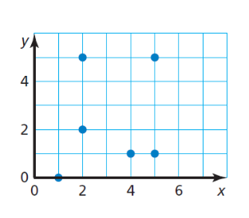 (5 points) b. (5 points)

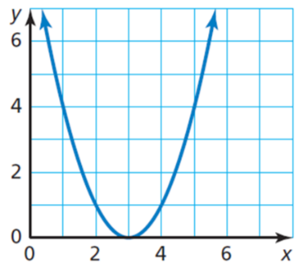

Function or not a function? Why?

Continuous or discrete? Why?

If f(x) =2, then x =

Function or not a function? Why?

Continuous or discrete? Why?

What is f(5) = ?

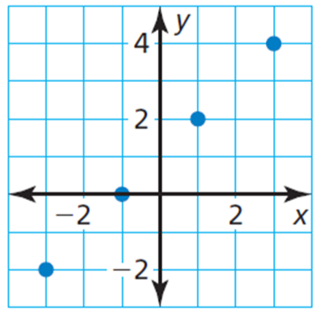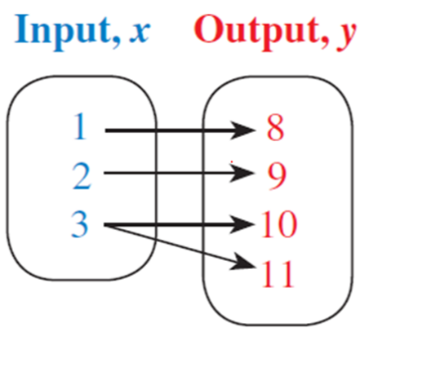

Function or not a function? Why?

Continuous or discrete? Why?

Domain:

Range:

Function or not a function? Why?

Continuous or discrete? Why?

1. On the graph provided, draw a relation that is:
2. 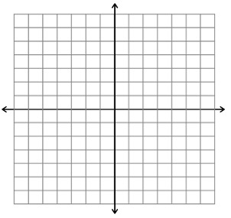 continuous and a function. (2 points) b. discrete and not a function. (2 points)



1. 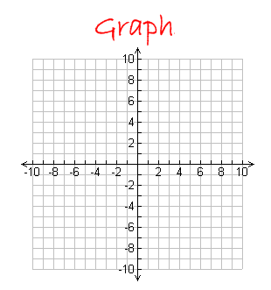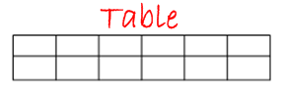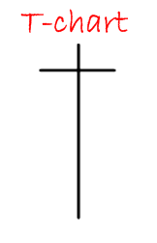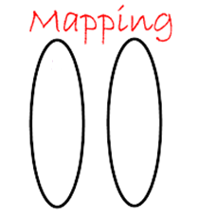 Given the relation {(0, -1), (0, 4), (6, 1), (8, 3), (3, 4)} visually represent the same relation in the following forms: mapping diagram, t-chart, table, and graph. (2 points each)
2. Find each value for the given function. (3 points each part)

$f\left(x\right)=2x^{2}+4x-8 g\left(x\right)= -\frac{4}{3}x+6$

$a. f\left(-3\right)= b. g\left(-1\right)=$

$$c. f\left(2\right)= d. g\left(2\right)=$$

1. Find the domain of the the function 6. Find the range of the function

when y = -2. (3 points) when x = 5. (3 points)

4x +2y = 6 y = x - 4

1. Match the relations on the left with a rule on the right. (1 point each)

|  |  |
| --- | --- |
| **X** | **Y** |
| 0 | 5 |
| 1 | 6 |
| 2 | 7 |
| 3 | 8 |
| 4 | 9 |

RULE

1. 
2. 
3. 

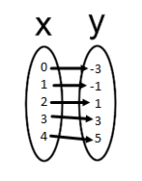

(0 , 0)

(1 , 1)

(2 , 4)

(3 , 9)

(4 , 16)

1. Will makes 8 dollars an hour bagging groceries at Hy-Vee.
2. Create a table to show this relation. (1 point)

b. Write a function to show Williams’s weekly salary (**S**) for the number of hours worked (**h**).

c. What is a reasonable place to start your domain values in your table and why? (2 points)

d. What is a reasonable range for this function and why? (2 points)

1. What is the independent variable? f. What is the dependent variable?

(1 point) (1 point)

1. If William works 24 hours a week, how much money will he make in one month before taxes?
2. points)
3. Solve each equation for x. (5 points each)

a. 10x – 4(x – 8) = 13 b. $\frac{x}{6}-4= 1$

1. Which number does not belong in the given set and why? (2 points)

6, $\frac{1}{3}$, $\sqrt{25}$, 6.4, $\sqrt{3}$