**Algebra 1 Unit 3 Test Review Name_________________________________________**

Complete each problem as directed. Show work for full credit. **Hr: ___________________**

1. Find the slope of the line that contains each pair of points and describe what the slope tells you about the graph of the line. (4 points each)
2. (1, 7) and (1, -3) b. (-8,2) and (-4, -4)
3. Write an equation in slope intercept form for each line. (1 point each)
4. Slope $\frac{-2}{3}$ and y-intercept of 5. b. slope 8 and the point (0,4).

_____________________ ____________________

1. Write an equation in point-slope form for the line containing (1,7) with slope 4, then convert the equation to slope-intercept form. (3 points)
2. Write an equation in point-slope form for the line that contains (2,5) and (-6,9). Convert the equation to slope-intercept and standard form. (5 points)
3. Write an equation for the line perpendicular to $y=\frac{2}{3}x+4$ with y-intercept (0,-2). (3 points)
4. Write an equation for the line parallel to $y=\frac{2}{3}x+4$ that contains (3, 5). (3 points)
5. Determine the slope of the following line: 5x + 3y = 30 (3 points)
6. Graph the equation 6x + 5y = 30 by finding the intercepts.

1. x-intercept. (3 points) Graph (4 points)



1. y-intercept. (3 points)
2. Graph the line containing (-1,3) 10. Use the slope and y-intercept to

with slope of $\frac{2}{5}$. (4 points) graph y = -4x + 5. (4 points)



1. Graph the equation $y-2=-3\left(x-1\right)$ (4 points)



1. Given the equations y = -4x + 3 and y = 3x – 4, which graph would have a steeper line, and how do you know? (4 points)
2. You are saving money to buy the most recent season of *Modern Family* on DVD. You have $7 saved and earn $5 each week walking the neighbor’s dog.
3. Make a coordinate graph to show the amount of money you have after walking the dog for 1, 2, 3, and 4 weeks. (4 points)
4. Find the rate of change in the amount of money you make as you walk the dog each week. Justify your response. (4 points)
5. Write an equation to describe the relationship between the money you have and the number of weeks you have been walking the dog. (2 points)
6. What is the y-intercept and what does it represent? (4 points)
7. Calculate the slope of the line from the graph.

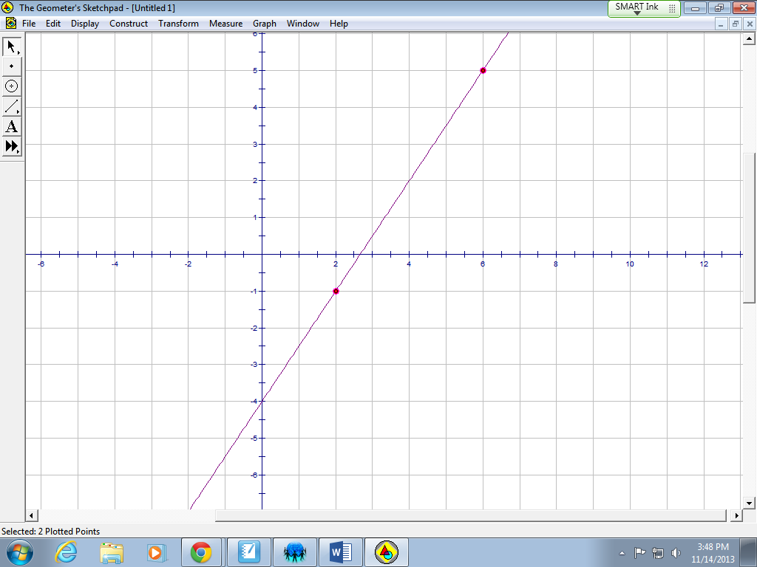(2 points)

Slope____________

1. Write the equation of the following graphs. (2 points each)
2. b.

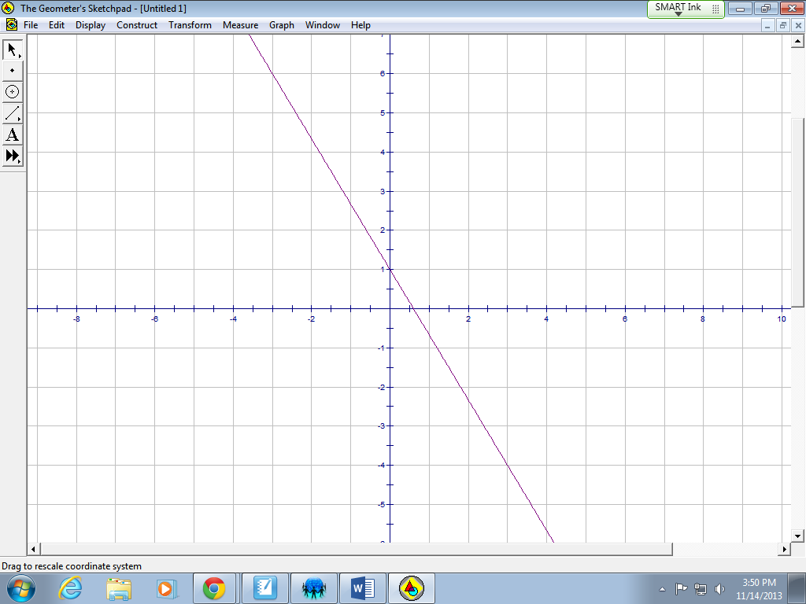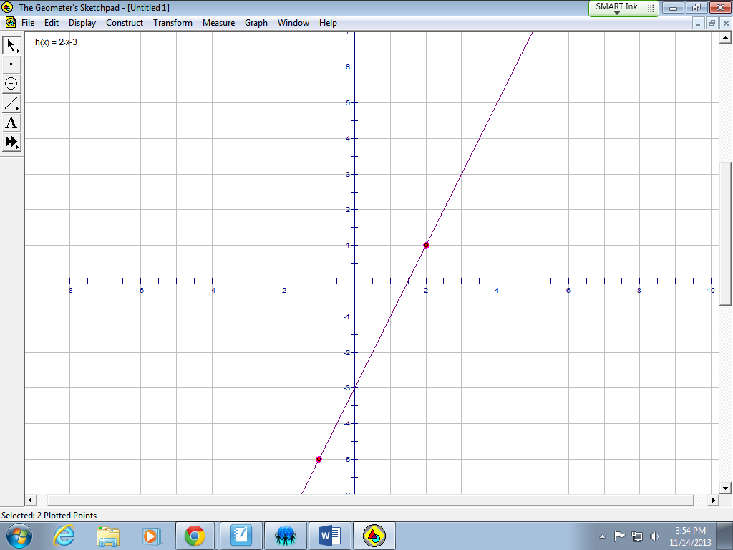

Equation_____________ Equation_____________

Write the equation of the line given by the tables below. (3 points each)

|  |  |  |  |  |  |
| --- | --- | --- | --- | --- | --- |
| x | 0 | 1 | 2 | 3 | 4 |
| y | 9 | 13 | 17 | 21 | 25 |



Equation:_________________

|  |  |  |  |  |  |
| --- | --- | --- | --- | --- | --- |
| x | 0 | 2 | 4 | 6 | 8 |
| y | 7 | 3 | -1 | -5 | -9 |



Equation:_________________

18.

|  |  |  |  |  |  |
| --- | --- | --- | --- | --- | --- |
| x | 3 | 6 | 9 | 12 | 15 |
| y | -10 | -8 | -6 | -4 | -2 |

Equation:_________________

1. Determine the x- and y-intercepts from the following graph:

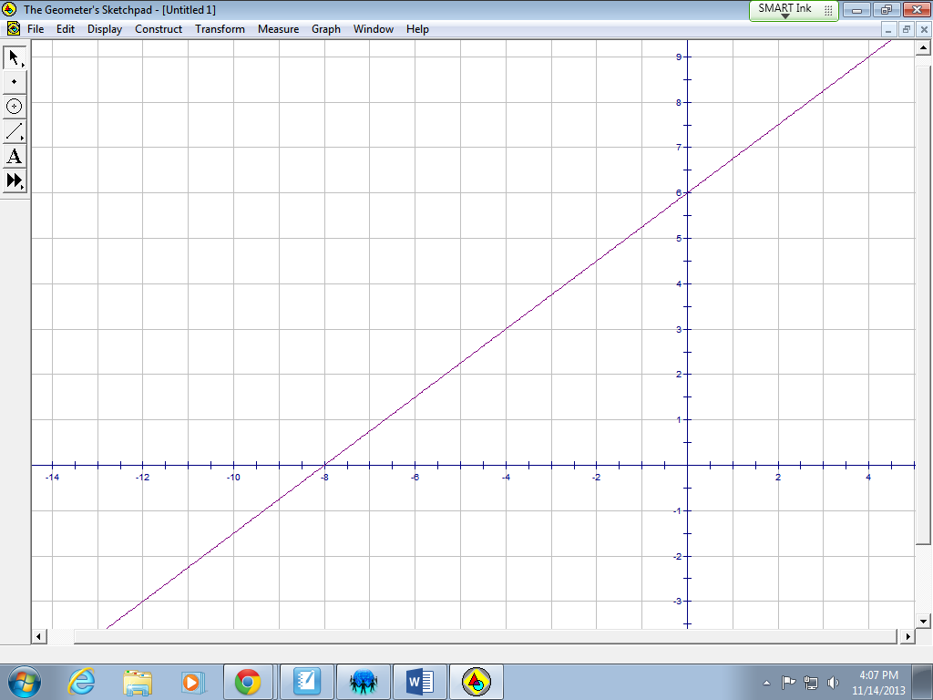 (2 points)

x-intercept________

y-intercept________

20. You get a loan in order to buy a car. The graph below shows your payment plan for his car loan.



You pay the same amount of money on his loan each month.

1. What does the *x*-intercept represent? (1 point)
2. What does the y-intercept represent? (1 point)
3. What does the slope represent? (1 point)
4. Solve each equation. (4 points each)
5. 2x – (5x + 8) = 32 b. 8 – 3n = 2n + 9
6. Simplify the expression. (5x – 6y) – (x + y)

(3 points)