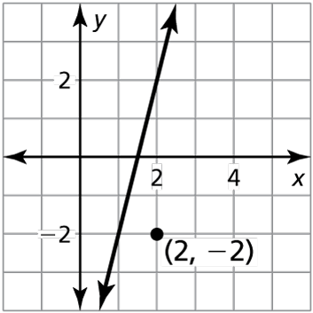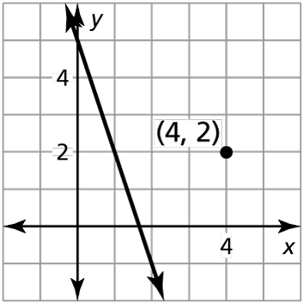Name Date

Homework 4.3

In Exercises 1 and 2, determine which of the lines, if any, are parallel. Explain.

1. Line *a* passes through  2. Line *a*: 

Line *b* passes through  Line *b*: 

Line *c* passes through  Line *c*: 

In Exercises 3 and 4, write an equation of the line that passes through the given point and is parallel to the given line.

3.  4. 

In Exercises 5 and 6, determine which of the lines, if any, are parallel or   
perpendicular. Explain.

5. Line *a* passes through  6. Line *a*: 

Line *b* passes through  Line *b*: 

Line *c* passes through  Line *c*: 

In Exercises 7 and 8, write an equation of the line that passes through the given point and is perpendicular to the given line.

7.  8. 

In Exercises 9 and 10, write an equation of the line that passes through the given point and is (a) parallel and (b) perpendicular to the given line.

9. 10.

In Exercises 11–13, determine whether the statement is *sometimes*, *always*, or *never* true. Explain your reasoning.

11. A line with a positive slope and a line with a negative slope are parallel.

12. A vertical line is perpendicular to the *x*-axis.

13. Two lines with the same *x*-intercept are perpendicular.

Name Date

Practice B

4.3

In Exercises 1 and 2, determine which of the lines, if any, are parallel. Explain.

1. Line *a* passes through  2. Line *a*: 

Line *b* passes through  Line *b*: 

Line *c* passes through  Line *c*: 

In Exercises 3 and 4, write an equation of the line that passes through the given point and is parallel to the given line.

3.  4. 

In Exercises 5 and 6, determine which of the lines, if any, are parallel or   
perpendicular. Explain.

5. Line *a* passes through  6. Line *a*: 

Line *b* passes through  Line *b*: 

Line *c* passes through  Line *c*: 

In Exercises 7 and 8, write an equation of the line that passes through the given point and is perpendicular to the given line.

7.  8. 

In Exercises 9 and 10, write an equation of the line that passes through the given point and is (a) parallel and (b) perpendicular to the given line.

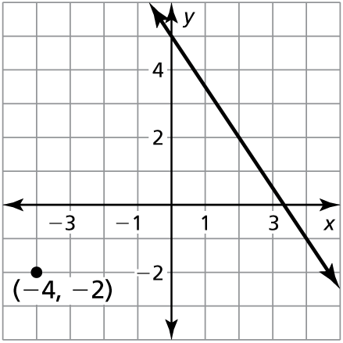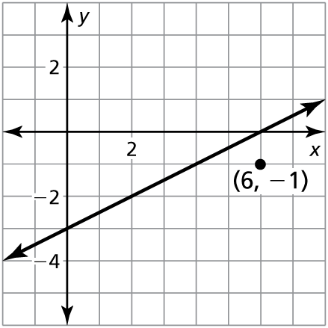 9. 10.

In Exercises 11–13, determine whether the statement is *sometimes*, *always*, or *never* true. Explain your reasoning.

11. A line with a positive slope and a line with a negative slope are perpendicular.

12. A vertical line and a horizontal line are perpendicular.

13. Two horizontal lines are perpendicular.