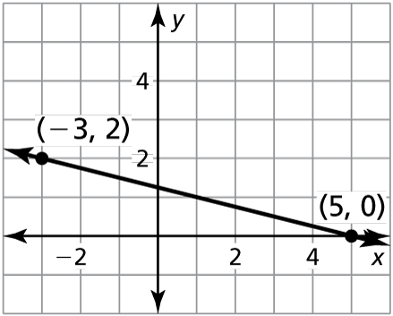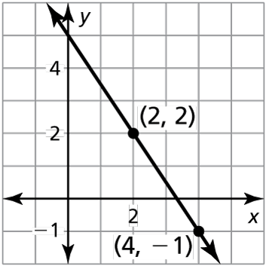Name Date

Homework 4.2

In Exercises 1–3, write an equation in point-slope form of the line that passes through the given point and has the given slope.

1.  2.  3. 

In Exercises 4 and 5, write an equation in slope-intercept form of the line shown.

4. 5.

In Exercises 6–8, write an equation in slope-intercept form of the line that passes through the given points.

6.  7.  8. 

In Exercises 9–11, write a linear function *f* with the given values.

9.  10.  11. 

In Exercises 12 and 13, tell whether the data in the table can be modeled by a linear equation. Explain. If possible, write a linear equation that represents *y* as a function of *x*.

12. 13.

|  |  |  |  |  |  |
| --- | --- | --- | --- | --- | --- |
| *x* | −2 | 0 | 2 | 4 | 6 |
| *y* | −3 | 9 | 3 | 6 | 9 |

|  |  |  |  |  |  |
| --- | --- | --- | --- | --- | --- |
| *x* | 1 | 3 | 5 | 7 | 9 |
| *y* | −2 | 4 | 7 | 14 | 22 |

14. You are renting a paddle board. The company charges a $50 fee and $20 per   
half-day.

a. Write an equation that represents the total cost (in dollars) of renting a paddle board as a function of the number of half-days.

b. Find the total cost of renting a paddle board for 7 half-days.

Name Date

Practice B

4.2

In Exercises 1–3, write an equation in point-slope form of the line that passes through the given point and has the given slope.

1.  2.  3. 

In Exercises 4 and 5, write an equation in slope-intercept form of the line shown.

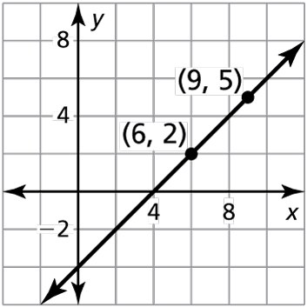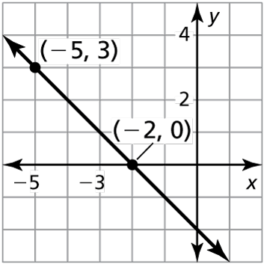 4. 5.

In Exercises 6–8, write an equation in slope-intercept form of the line that passes through the given points.

6.  7.  8. 

In Exercises 9–11, write a linear function *f* with the given values.

9.  10.  11. 

In Exercises 12 and 13, tell whether the data in the table can be modeled by a linear equation. Explain. If possible, write a linear equation that represents *y*   
as a function of *x*.

12. 13.

|  |  |  |  |  |  |
| --- | --- | --- | --- | --- | --- |
| *x* | 0 | 1 | 2 | 3 | 4 |
| *y* | 3.5 | 3 | 2.5 | 2 | 1.5 |

|  |  |  |  |  |  |
| --- | --- | --- | --- | --- | --- |
| *x* | 0 | 2 | 4 | 6 | 8 |
| *y* | 1 | 2 | 4 | 8 | 16 |

14. The equation  represents the cost (in dollars) of making your own juice (in fluid ounces).

a. What is the slope of the line? Interpret the slope in the context of this situation.

b. Write the equation as a linear function.

c. Use the linear function in part (b) to determine the base cost of making your own juice.