Name Date

Homework 4.1

In Exercises 1–3, write an equation of the line with the given slope and *y*-intercept.

1. slope: 3 2. slope:  3. slope: 0

*y*-intercept: 8 *y*-intercept: 0 *y*-intercept: 

In Exercises 4 and 5, write an equation of the line in slope-intercept form.

4. 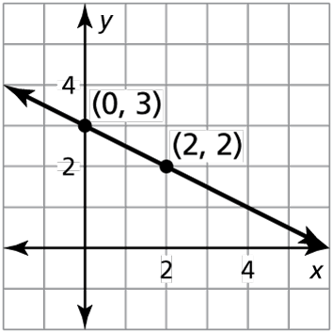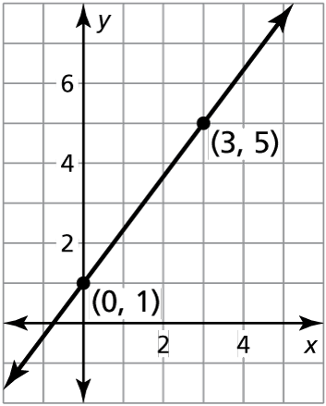5.

In Exercises 6–8, write an equation of the line that passes through the   
given points.

6.  7.  8. 

In Exercises 9–11, write a linear function *f* with the given values.

9.  10.  11. 

12. In 2003, a gallon of gas cost $1.75. In 2013, a gallon of gas cost $3.50.

a. Write a linear model that represents the cost (in dollars) of a gallon   
of gas as a function of the number of years since 2003.

b. Use the model to predict the cost of a gallon of gas in 2023.

13. Line  is a reflection in the *y*-axis of line *k*. Write an equation that represents   
line *k*.

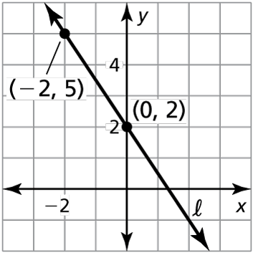

Name Date

Practice B

4.1

In Exercises 1–3, write an equation of the line with the given slope and *y*-intercept.

1. slope: 3 2. slope: 0 3. slope: 

*y*-intercept:  *y*-intercept:  *y*-intercept: 7

In Exercises 4 and 5, write an equation of the line in slope-intercept form.

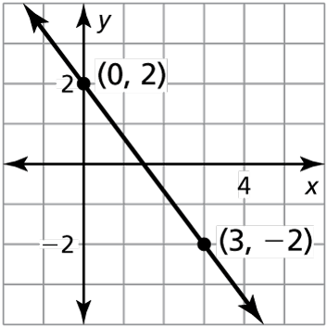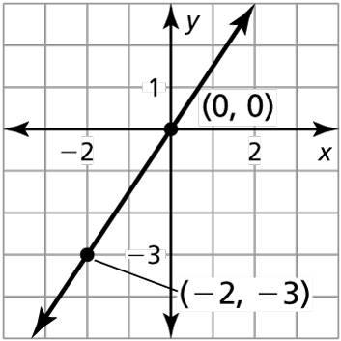 4. 5.

In Exercises 6–8, write an equation of the line that passes through the   
given points.

6.  7.  8. 

In Exercises 9–11, write a linear function *f* with the given values.

9.  10.  11. 

12. A T-shirt design company charges your team an initial fee of $25 to create the team's design. Each T-shirt printed with your design costs an additional $8.

a. Write a linear model that represents the total cost of purchasing your team’s   
T-shirts with your design as a function of the number of T-shirts.

b. Your team has 35 members. If a T-shirt is purchased for every member,   
what would be the cost?

13. Line  is a reflection in the *x*-axis of line *k*. Write an equation that represents   
line *k*.

