Name Hour

Solving Inequalities Using Addition and Subtraction

HW 2.2

Solve the inequality. Graph the solution.

1.  2.  3. 

4.  5.  6. 

7.  8.  9. 

Write the sentence as an inequality. Then solve the inequality.

10. The difference of a number and 6 is less than 1.

11. Eight is greater than or equal to the sum of a number and 3.

12. You and your friend are planning to walk across an old bridge. The bridge can hold at most 1000 pounds. The total weight of the people currently on the bridge   
is 675 pounds. You weigh 156 pounds.

a. Write and solve an inequality that represents how much your friend can   
weigh within the limits of the bridge.

b. Your friend weighs 182 pounds. Can you and your friend both walk on   
the bridge? Explain.

Name Date

Practice B

2.2

In Exercises 1–9, solve the inequality. Graph the solution.

1.  2.  3. 

4.  5.  6. 

7.  8.  9. 

In Exercises 10–13, write the sentence as an inequality. Then solve the inequality.

10. A number plus 10 is less than 34.

11. A number minus 8 is at least 14.

12. The sum of a number and 7 is less than 15.

13. Nine is less than or equal to the difference of a number and 1.

14. You order a new pair of running shoes from a website that offers free shipping on orders of $75 or more. Your shoes cost $69.95.

a. Write and solve an inequality that represents how much more you must spend to get free shipping.

b. The cost of shipping your shoes is $7.79. Would you purchase another item in order to get free shipping? Explain.

In Exercises 15 and 16, write and solve an inequality to find the possible values   
of *x*.

15.  16. 

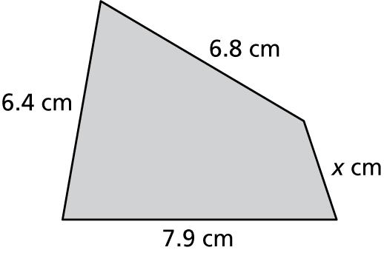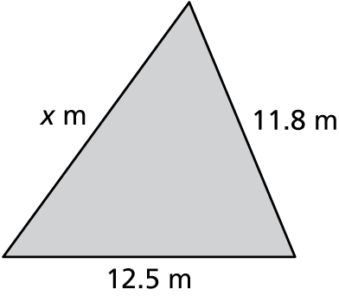

17. Write and solve an inequality that represents the numbers that are *not* solutions of each inequality.

a.  b. 