Name Hour

Factoring x^2+bx+c

Show all work on a separate sheet of paper.

HW 7.5

In Exercises 1–12, factor the polynomial.

1.  2.  3. 

4.  5.  6. 

7.  8.  9. 

10.  11.  12. 

13. A projector displays a rectangular image on a wall. The height of the wall is *x* feet. The area (in square feet) of the projection is represented by  The width of the projection is 

a. Write a binomial that represents the height of the projection.

b. Find the perimeter of the projection when the height of the wall is 10 feet.

14. Describe and correct the error in factoring the polynomial.



In Exercises 15 and 16, find the dimensions of the polygon with the given area.

15.  16. 

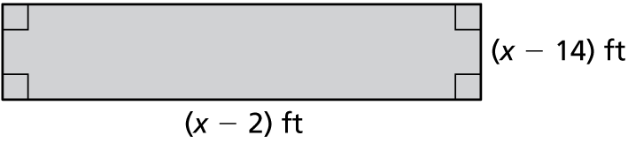 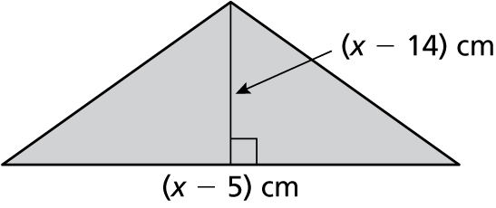

17. Write an equation of the form  that has the solutions ** Explain how you found your answer.

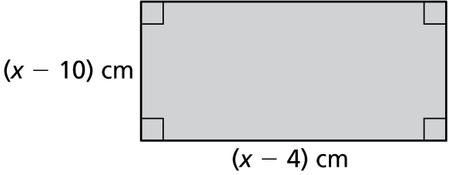Name Date

Practice B

7.5

In Exercises 1–12, factor the polynomial.

1.  2.  3. 

4.  5.  6. 

7.  8.  9. 

10.  11.  12. 

13. Describe and correct the error in factoring the polynomial.



In Exercises 14 and 15, find the dimensions of the polygon with the given area.

14.  15. 

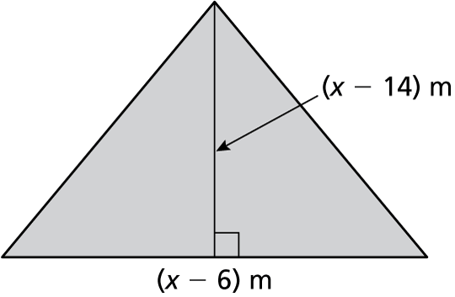

16. The graph shows 

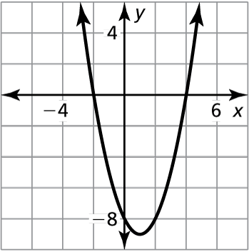

a. Explain how you can use the graph to factor the polynomial.

b. Factor the polynomial.