Name Hour

Solving Polynomial Equations in Factored Form

Show all work on a separate sheet of paper.

HW 7.4

In Exercises 1–9, solve the equation.

1.  2.  3. 

4.  5.  6. 

7.  8.  9. 

**In Exercises 10 and 11, find the *x*-coordinates of the points where the graph crosses the *x*-axis.**

10. 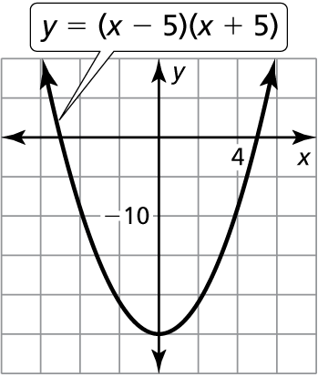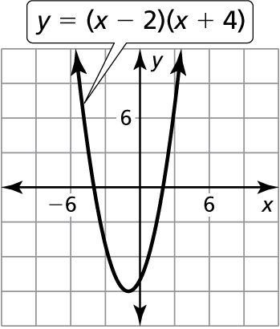 11.

In Exercises 12–14, factor the polynomial.

12.  13.  14. 

In Exercises 15–17, solve the equation.

15.  16.  17. 

18. Describe and correct   
the error in solving   
the equation.





19. The height *y* of a jumping frog can be modeled by where *x* is the time (in seconds) since the frog jumped from the ground. Find the roots of the equation when ** Explain what the roots mean in this situation.

Name Date

Practice B

7.4

In Exercises 1–9, solve the equation.

1.  2. 

3.  4. 

5.  6. 

7.  8. 

9. 

**In Exercises 10 and 11, find the *x*-coordinates of the points where the graph crosses the *x*-axis.**

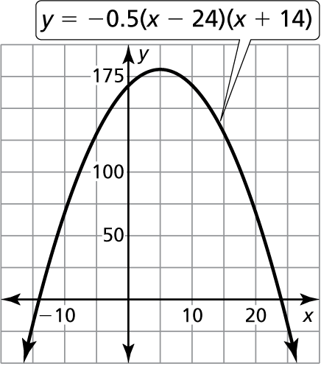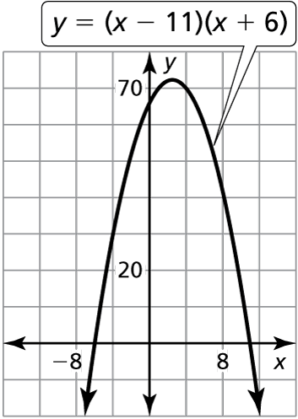 10. 11.

In Exercises 12–14, factor the polynomial.

12.  13.  14. 

In Exercises 15–17, solve the equation.

15.  16.  17. 

18. Describe and correct   
the error in solving   
the equation.



The root is 

19. Write a polynomial of degree 3 whose only roots are  and  Is there another polynomial of degree 3 that has the same roots?