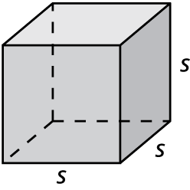Nam Hour Date

Radicals and Rational Exponents

HW 6.2

In Exercises 1 and 2, rewrite the expression in rational exponent form.

1.  2. 

In Exercises 3 and 4, rewrite the expression in radical form.

3.  4. 

In Exercises 5 and 6, find the indicated real *n*th root(s) of *a*.

5. ** 6. **

In Exercises 7 and 8, find the dimensions of the cube. Check your answer.

7. 8. 

In Exercises 9–11, evaluate the expression.

9.  10.  11. 

In Exercises 12 and 13, rewrite the expression in rational exponent form.

12.  13. 

In Exercises 14 and 15, rewrite the expression in radical form.

14.  15. 

In Exercises 16–18, evaluate the expression.

16.  17.  18. 

19. The area of a square patio is square inches. Find the length of one side   
of the patio.

Name Date

Practice B

6.2

In Exercises 1 and 2, find the indicated *n*th root(s) of *a*.

1.  2. 

In Exercises 3 and 4, find the dimensions of the cube. Check your answer.

3. 4. 



In Exercises 5–7, evaluate the expression.

5.  6.  7. 

In Exercises 8 and 9, rewrite the expression in rational exponent form.

8.  9. 

In Exercises 10 and 11, rewrite the expression in radical form.

10.  11. 

In Exercises 12–17, evaluate the expression.

12.  13.  14. 

15.  16.  17. 

18. The radius of a sphere is given by the equation  where *V* is the volume of the sphere. Find the radius, to the nearest centimeter, of a sphere that has a volume of 268 cubic centimeters. Use 3.14 for 

19. Use the formula  to find the annual inflation rate to the nearest tenth of a percent. A rare coin increases in value from $0.25 to $1.50 over a   
period of 30 years.