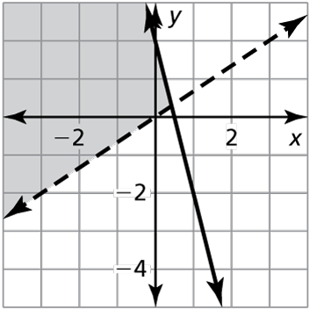Name Hour

Systems of Linear Inequalities

HW 5.7

In Exercises 1–4, tell whether the ordered pair is a solution of   
the inequality whose graph is shown.

1.  2. 

3.  4. 

In Exercises 5 and 6, tell whether the ordered pair is a solution   
of the system of linear inequalities.

5.  6. 

In Exercises 7–12, graph the system of linear inequalities.

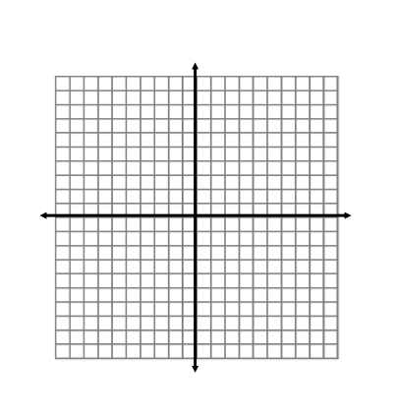 7.  8.  9. 

10.  11.  12. 

Name Date

Practice B

5.7

In Exercises 1 and 2, tell whether the ordered pair is a solution of the system of linear inequalities.

1.  2. 

In Exercises 3–8, graph the system of linear inequalities.

3.  4.  5. 

6.  7.  8. 

In Exercises 9 and 10, write a system of linear inequalities represented by   
the graph.

9. 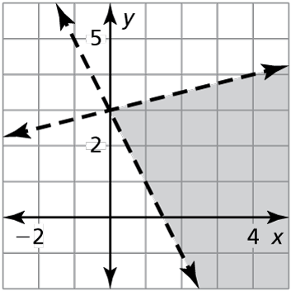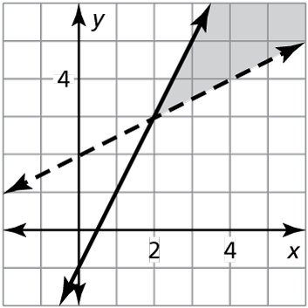 10.

11. Describe and correct the error in graphing the system of inequalities.





12. The points  are the vertices of a shaded triangle.

a. Write a system of linear inequalities represented by the shaded triangle.

b. Find the area of the triangle.