Name Hour

Graphing Linear Inequalities in Two Variables

HW 5.6

In Exercises 1–4, tell whether the ordered pair is a solution of the inequality.

1.  2. 

3.  4. 

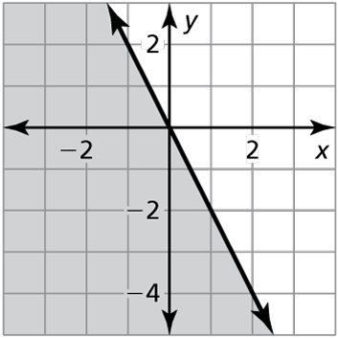In Exercises 5–10, tell whether the ordered pair is a solution of the inequality whose graph is shown.

5.  6.  7. 

8.  9.  10. 

11. You have $150 to spend on video games. The inequality represents the number *x* of used video games and the number *y* of new video games that you can purchase. Can you purchase 10 used video games and   
3 new video games? Explain.

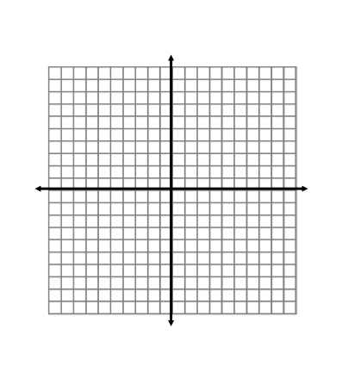

In Exercises 12–17, graph the inequality in a coordinate plane.

12.  13.  14. 



15.  16.  17. 

Name Date

Practice B

5.6

In Exercises 1–4, tell whether the ordered pair is a solution of the inequality.

1.  2. 

3.  4. 

5. The inequality represents the number *x* of newspapers and the number *y* of magazines you must sell to earn enough points to earn a special school lunch. You sell four newspapers and six magazines. Do you receive a special school lunch? Explain.

In Exercises 6–11, graph the inequality in a coordinate plane.

6.  7.  8. 

9.  10.  11. 

In Exercises 12 and 13, write an inequality that represents the graph.

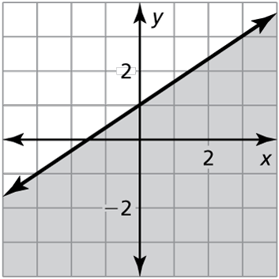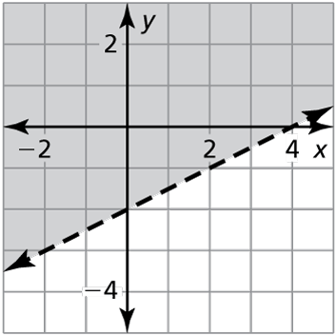 12. 13.

14. Write a linear inequality in two variables that has the following two properties.

* 
* 

In Exercises 15 and 16, write and graph an inequality whose graph is described by the given information.

15. The points lie on the boundary line. The points   
and are *not* solutions of the inequality.

16. The points lie on the boundary line. The points   
and are solutions of the inequality.