Name Hour

Solving Absolute Value Inequalities

HW 2.6

In Exercises 1–9, solve the inequality. Graph the solution, if possible.

1.  2.  3. 

4.  5.  6. 

7.  8.  9. 

10. The rules for a book report say that the report should have 300 words with an absolute deviation of at most 20 words. Write and solve an absolute value inequality that represents the acceptable number of words.

11. Describe and correct the error in solving the absolute value inequality.



12. Write an absolute value inequality that 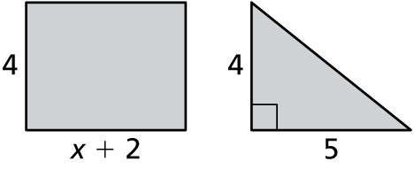  
represents the situation. Then solve the   
inequality. The difference between the   
areas of the figures is at most 6.

Name Date

Practice B

2.6

In Exercises 1–9, solve the inequality. Graph the solution, if possible.

1.  2.  3. 

4.  5.  6. 

7.  8.  9. 

10. The thermometer in a freezer is set at  This temperature varies by up to throughout the day. Write and solve an absolute value inequality that represents the range of temperatures (in degrees Fahrenheit) of the freezer throughout the day.

11. Describe and correct the error in solving the absolute value inequality.



In Exercises 12–14, write the sentence as an absolute value inequality. Then solve the inequality.

12. A number is more than 12 units from 0.

13. One-third of a number is at least 5 units from 31.

14. Twice a number is no more than 7 units from 13.

15. Write an absolute value inequality that represents the situation. Then solve the inequality. The difference between the perimeters of the figures is not greater   
than 10.

