Name Hour

Solving Multi-Step Inequalities

HW 2.4

In Exercises 1–3, match the inequality with its graph.

1.  2.  3. 

A. 

B.



C. 

In Exercises 4–9, solve the inequality. Graph the solution.

4.  5.  6. 

7.  8.  9. 

In Exercises 10–17, solve the inequality.

10.  11. 

12.  13. 

14. The area of the rectangle shown is at most 140 square centimeters.

a. Write and solve an inequality to find the possible   
values of *x*.

b. Based on the answer in part (a), is it possible for 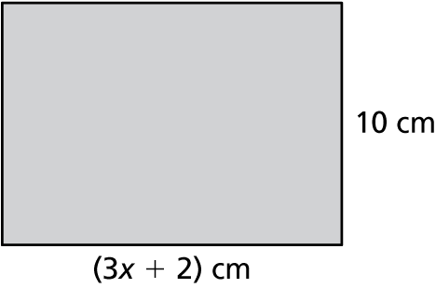  
the rectangle to have a length of 15 centimeters?   
Explain.

Name Date

Practice B

2.4

In Exercises 1–3, match the inequality with its graph.

1.  2.  3. 

 A.

 B.

 C.

In Exercises 4–9, solve the inequality. Graph the solution.

4.  5.  6. 

7.  8.  9. 

In Exercises 10–15, solve the inequality.

10.  11. 

12.  13. 

14.  15. 

16. You must maintain a minimum balance of $50 in your checking account.   
You currently have a balance of $280.

a. Write and solve an inequality that represents how many $20 bills you   
can withdraw from the account without going below the minimum   
balance.

b. Your bank charges an ATM fee of $2.50, which is charged each time   
you withdraw $20. Write and solve an inequality that represents how   
many $20 bills you can withdraw from the account without going   
below the minimum balance in this situation.